**Samsung LED Smart TV**

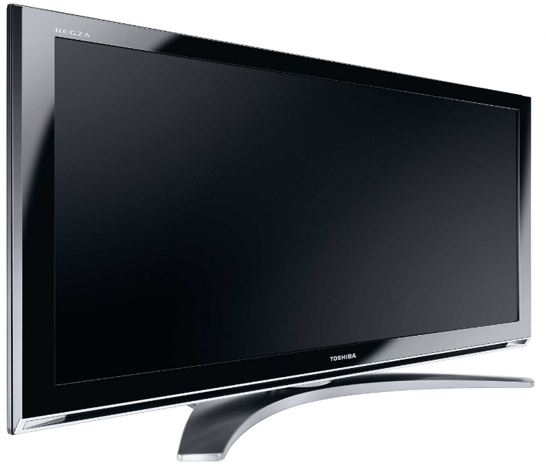

**Key Features  
  
 See Below Description for Installation & EMI Details  
 Technical Assistance: 0301-8226675 (Mon - Fri; 10AM - 7PM)  
 Brand Warranty  
 Screen Size: 40"  
 Screen Type: HD LED  
 Screen Resolution: 1920 x 1080  
 Price per Unit: $450/-**

**CORPORATE OFFICE**

    1300 E. Control Tower Rd.  
    Suite 216 Block L3  
    Englewood CO 80112  
 Phone: 720.974.7878  
    Toll Free: 1.877.929.7878  
    Email: [info@choicescreening.com](mailto:info@choicescreening.com)